Being Stoned

~ Deacon Matthew Pierce ~

1 Peter 4:12-13 (KJV)
¹² Beloved, think it not strange concerning the fiery trial which is to try you, as though some strange thing happened unto you: ¹³ But rejoice, inasmuch as ye are partakers of Christ's sufferings; that, when his glory shall be revealed, ye may be glad also with exceeding joy.

John 16:33 (KJV)
³³ These things I have spoken unto you, that in me ye might have peace. In the world ye shall have tribulation: but be of good cheer; I have overcome the world.

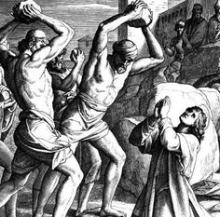

Stone #1 (devil’s schemes)
Worries, Stress, Doubt, Burdens, Regrets, Confusion, Daily Aggravation

Matthew 6:34 (NIV)
³⁴ Therefore do not worry about tomorrow, for tomorrow will worry about itself. Each day has enough trouble of its own.

Revelation 2:24b (KJV) ^{24b} …I will put upon you none other burden.

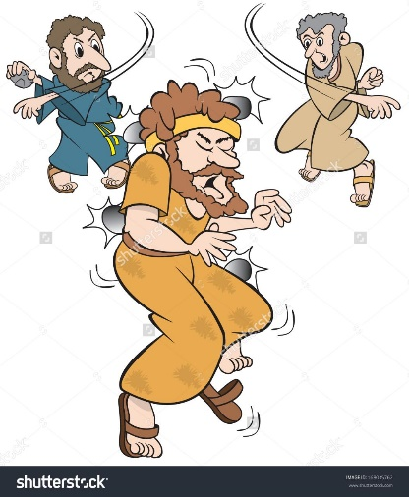

Stone #2 (devil’s attacks)
Grief, Torment, Doubt, Sorrow, Tragedy, Pain

Ephesians 6:13 (KJV)
¹³ Wherefore take unto you the whole armour of God, that ye may be able to withstand in the evil day, and having done all, to stand.

John 16:20 (KJV)
²⁰ Verily, verily, I say unto you, That ye shall weep and lament, but the world shall rejoice: and ye shall be sorrowful, but your sorrow shall be turned into joy.

Psalm 126:5 (KJV) ⁵ They that sow in tears shall reap in joy.

Matthew 24:7-8 (KJV)
⁷ For nation shall rise against nation, and kingdom against kingdom: and there shall be famines, and pestilences, and earthquakes, in divers places. ⁸ All these are the beginning of sorrows.
Psalm 27:1 | Isaiah 41:13 | 2 Timothy 2:23-24
James 1:19-21 | 1 Peter 5:7 | Romans 12:1
Romans 5:3-4 | Romans 8:17-18 | James 1:12

Psalm 25:16-19 (KJV)
¹⁶ Turn thee unto me, and have mercy upon me; for I am desolate and afflicted. ¹⁷ The troubles of my heart are enlarged: O bring thou me out of my distresses. ¹⁸ Look upon mine affliction and my pain; and forgive all my sins. ¹⁹ Consider mine enemies; for they are many; and they hate me with cruel hatred.
BUT WE HAVE THE VICTORY IN CHRIST JESUS OUR LORD

